**SourceTree tutorial**

1. **Как се добавя GitHub акаунт ?**

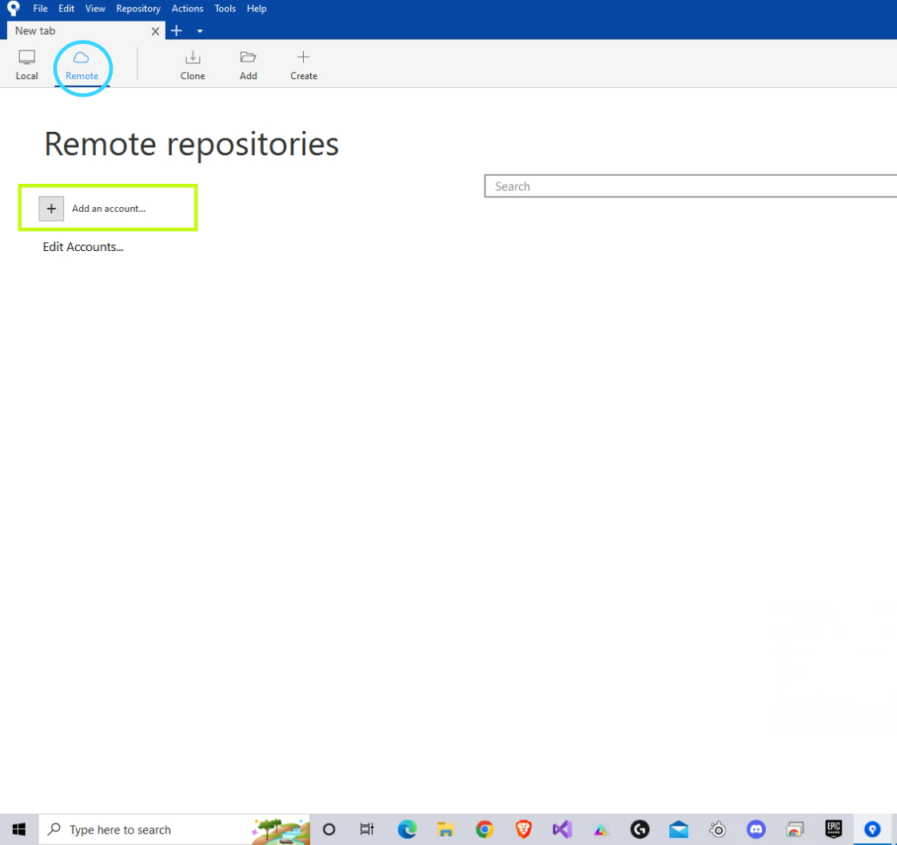

1. **Graphical user interface, text, application, email

   Description automatically generatedКак се клонират хранилища от Remote в Local ?**

1. **Graphical user interface, application, Word

   Description automatically generatedКак се създава локално хранилище ?**

1. **Graphical user interface, application, Word

   Description automatically generatedКак се commit-ват файлове ?**

1. **Graphical user interface, application

   Description automatically generatedКак се push-ват файлове ?**

